Session 3
1.Create a table called Playlist with columns: id (INT, primary key), song_name (VARCHAR), artist (VARCHAR), and duration (INT, seconds). Insert a single row for your current favorite song.
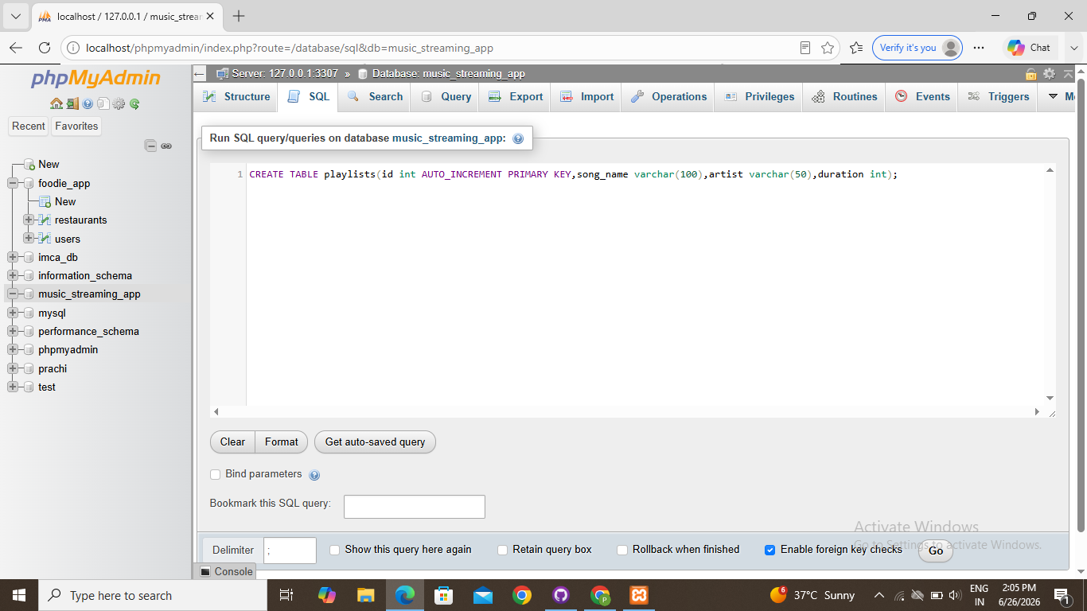
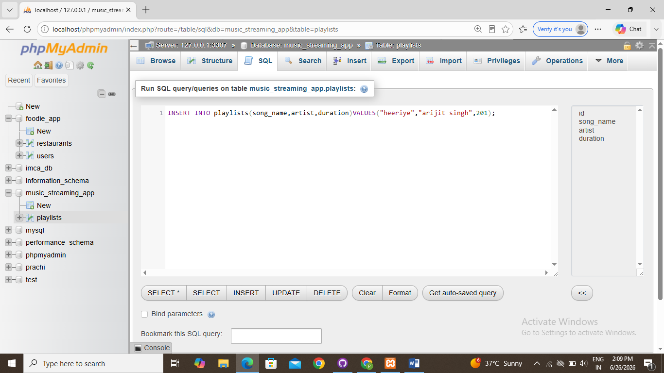

2.Insert 3 new rows into the Playlist table for songs you recently listened to on Spotify, including their song_name, artist, and duration.
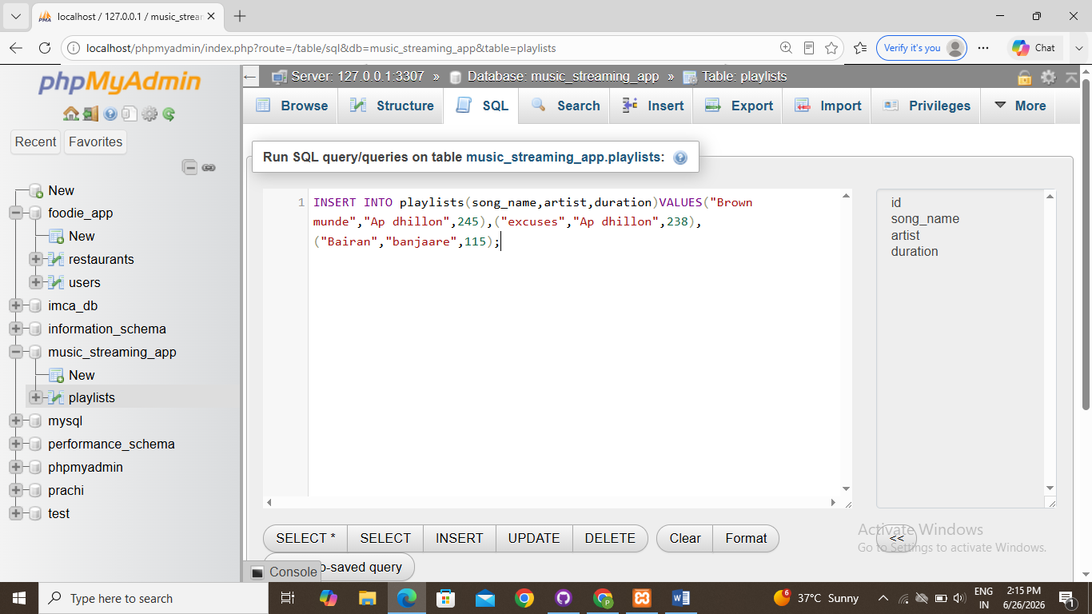

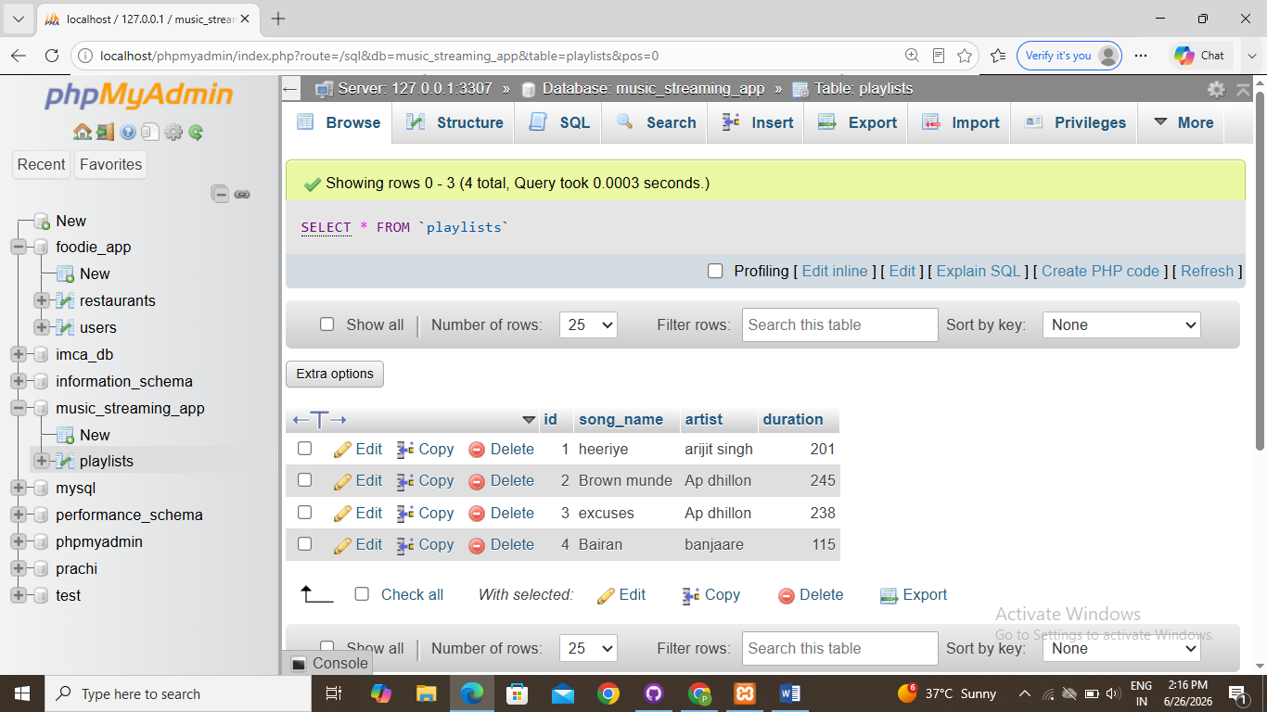
3.Update the artist name for one of your Playlist entries to fix a typo (for example, change 'Arjit Singh' to 'Arijit Singh') using the UPDATE statement with a WHERE clause.
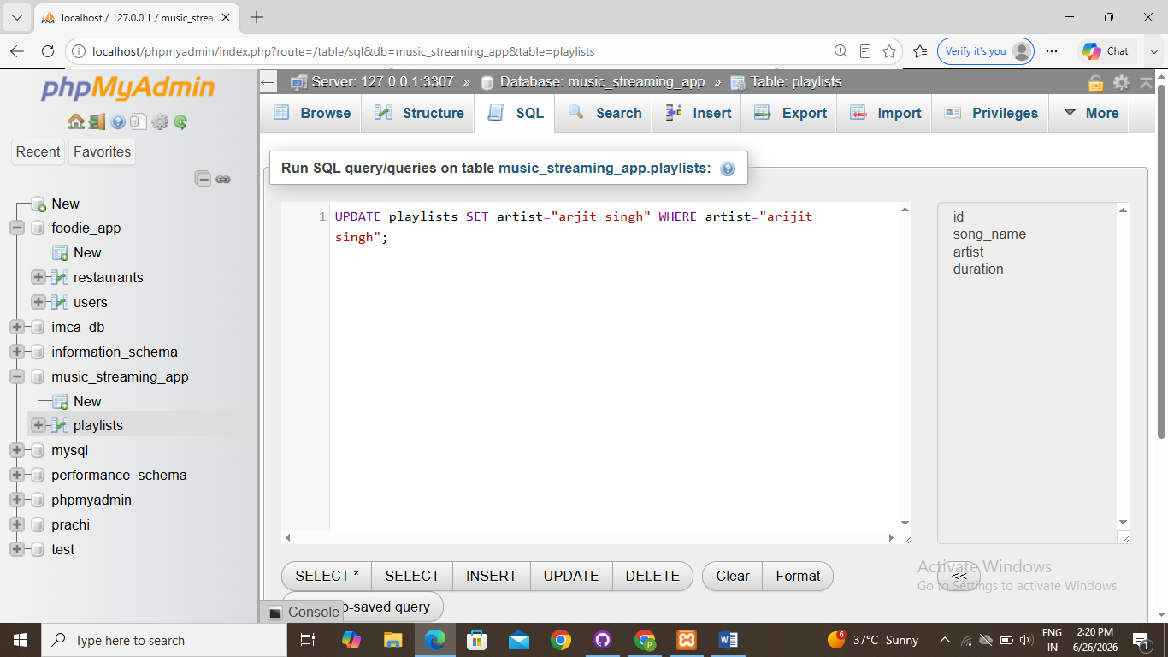
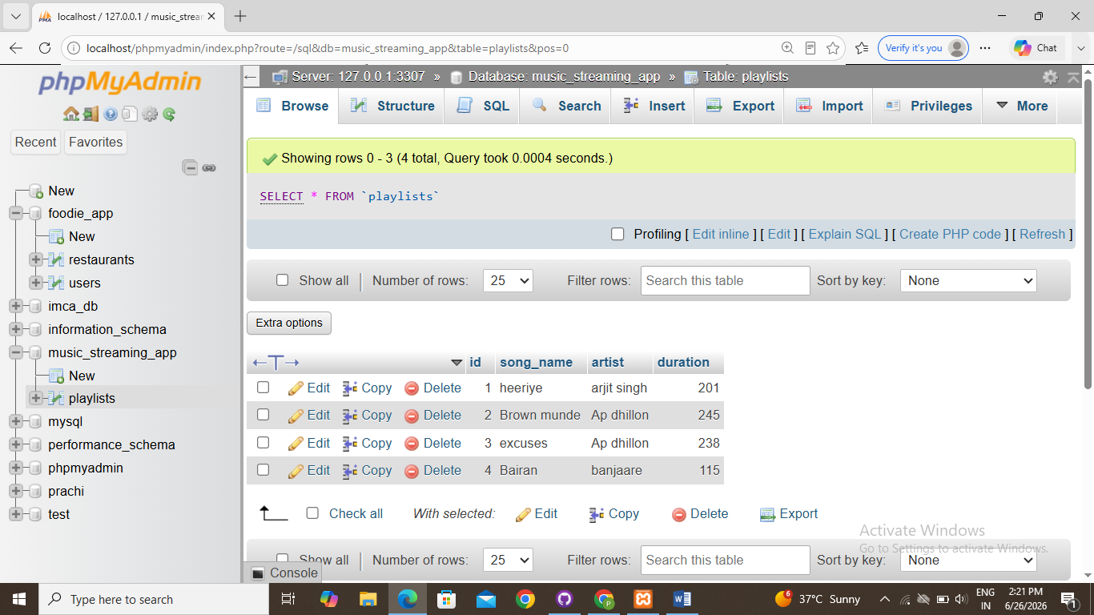
4.Delete a song from the Playlist table where the duration is less than 120 seconds using the DELETE statement and a WHERE clause.<br><br><em><strong>Hint:</strong> Make sure your WHERE clause is specific so you don’t accidentally delete all rows.</em>
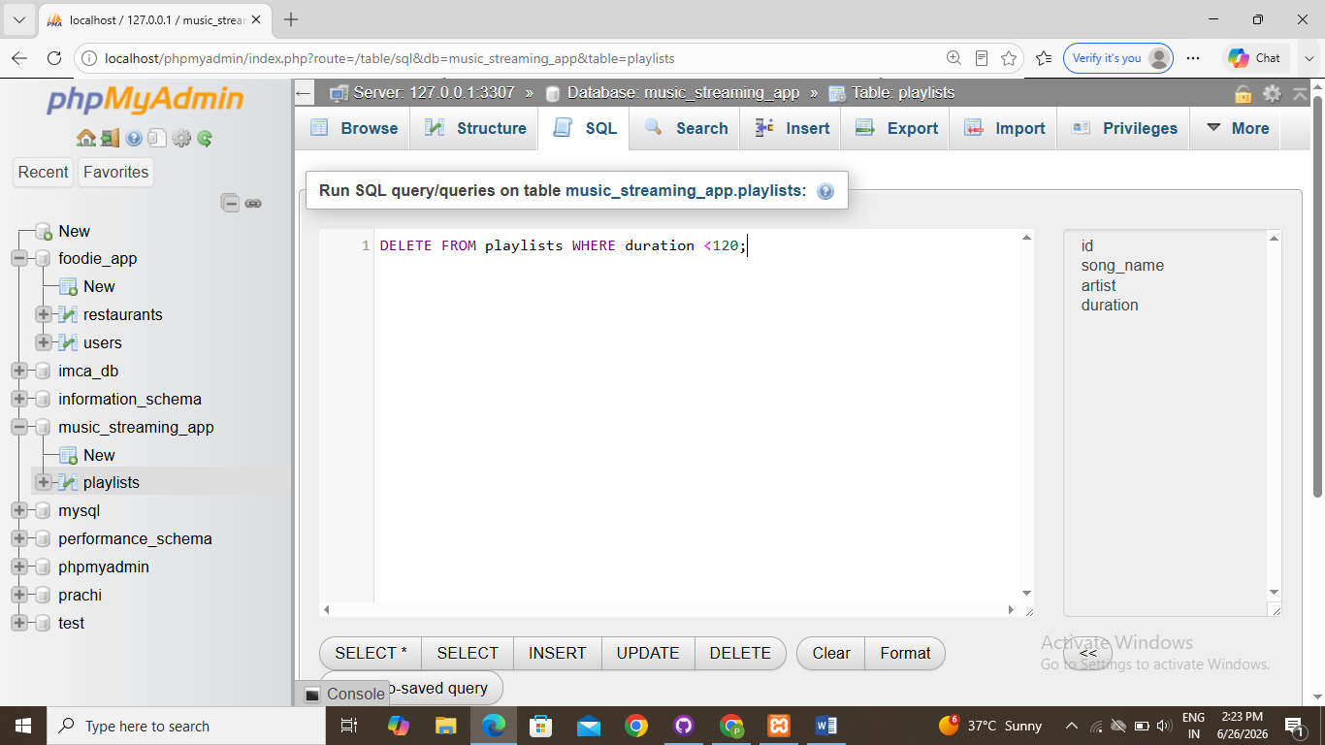
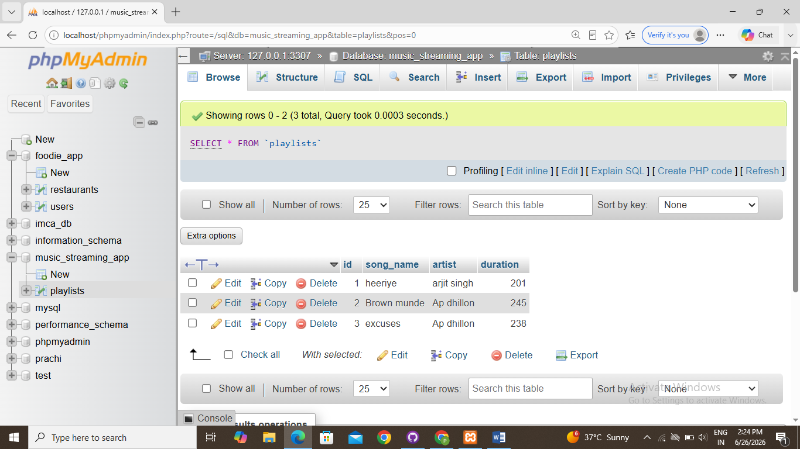
5.Write an SQL statement that would update the song_name for all songs by 'AP Dhillon' in your Playlist to add '(Remix)' at the end of the name, but only if the duration is more than 180 seconds.<br><br><em><strong>Constraint:</strong> Combine UPDATE with WHERE to target only the correct rows.</em>
